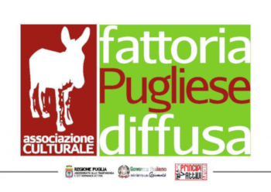
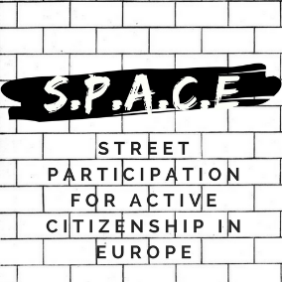

08 June 2018
Press release
SPACE: STREET PARTICIPATION FOR ACTIVE CITIZENSHIP IN EUROPE
THE SECOND EVENT – „TRAINING COURSE OF THE STREET FACILITATORS”
TRICASE, ITALY

Starting from the 4th to the 7st of June 2018, Fattoria Pugliese Diffusa Asssociazione Culturale (FPD) was the host of the second international event of the „SPACE: Street Participation for Active Citizenship in Europe”, which took place in Tiggiano and Tricase. The meeting was attended by 27 international participants from 10 countries, as well as local citizens. The aim of this meeting was to improve the required skills in order to become a „Street Facilitator”.
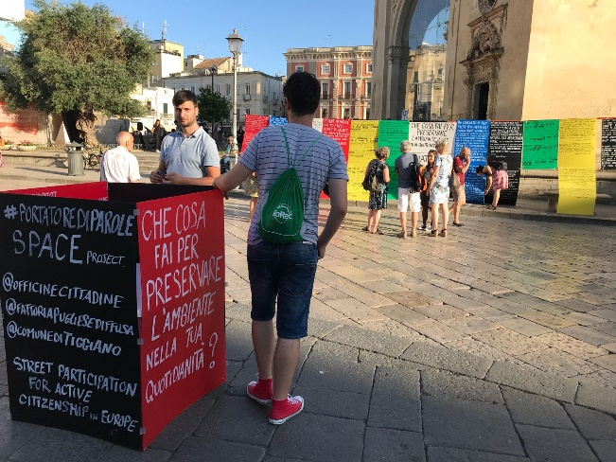
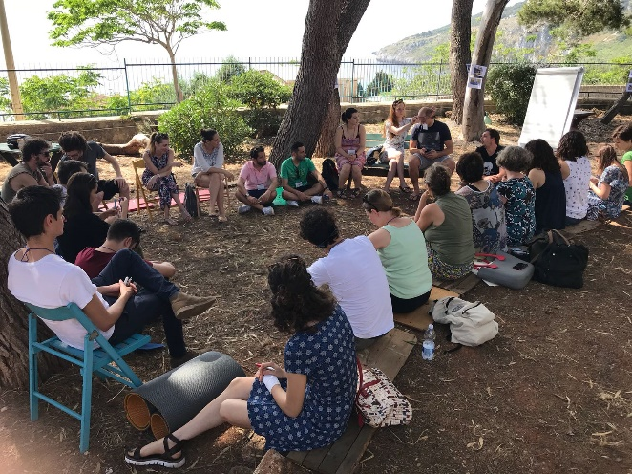
The official welcome started on the 5th of June with who’s who activities. The first part of the day began with the introduction in the street debate methodology and after the lunch each participant got a task in order to prepare the debate that took place in Lecce, in Piazza Sant’Oronzo. The day was very important because participants got the chance to manage some „Street Interactions”, skill that will be necessary for their local context.
The 3rd day was reserved for feedbacks and social interaction, so in order to manage the local events, a tool „Guideline: Street Interaction for citizens participation” has been published. After the luch, the participants started to preparation of the European local event and discussed about the sociology of Public Space and how to choose a proper question.
For more information on the event please visit: https://www.facebook.com/STREETPARTICIPATION/

