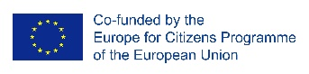
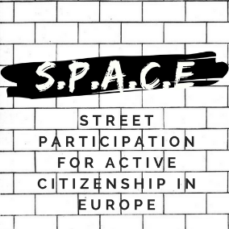

10 October 2018
Press release
SPACE: STREET PARTICIPATION FOR ACTIVE CITIZENSHIP IN EUROPE
THE THIRD EVENT – „DISSEMINATION SEMINAR”
TALLINN, ESTONIA

Starting from the 6th to the 9st of October 2018, „INVOLVED” organization was the host of the third international event of the „SPACE: Street Participation for Active Citizenship in Europe” project. The meeting took place in Tallinn. At the meeting attended 31 international participants from 10 countries, as well as local citizens. The aim of the meeting was to share the local experience of street debate.
On the day of 7th , the day started with some energizers and keep to know each other activities. The seminar continued with the introduction of the project and sharing the street debate experience at local level implemented by the project partners, with the topic „How important is Europe for you?”. During the second part of the day participants prepared the „European Street Debate” and implemented it in the old town of Tallinn.
The first part of the 3rd day, started with feedbacks and exchanges of how the participants felt during the street debate and what kind of issues they encountered. The meeting moved on to the topic of active citizenship in Estonia at which participants met with a local Civil Society organization. After the luch, participants started to prepare the next street debate about „the future of Europe”. The day ended with feedbacks and evaluation.
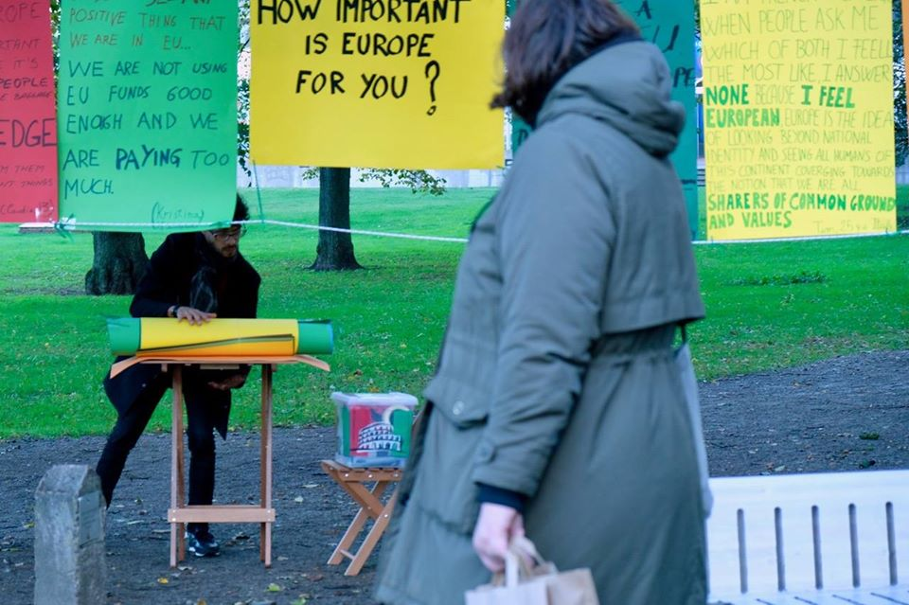
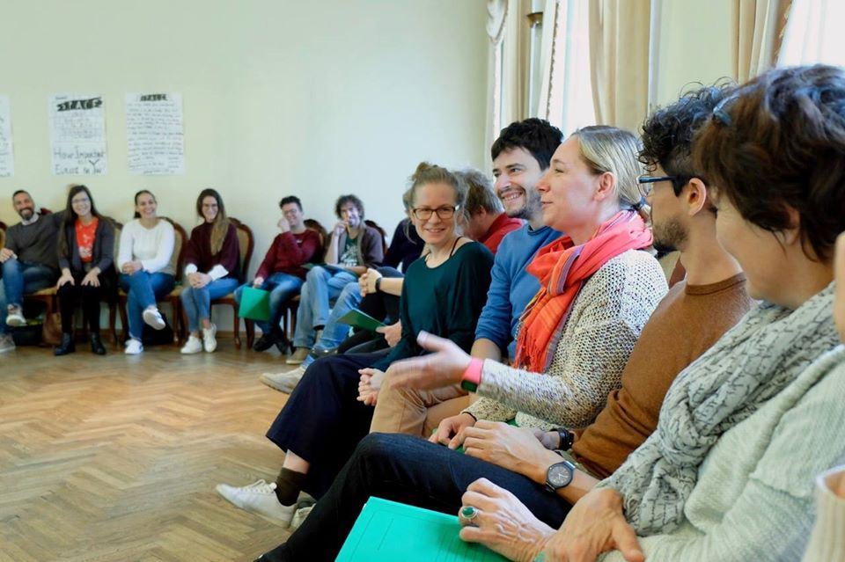
For more information on the event please visit: https://www.facebook.com/STREETPARTICIPATION/

