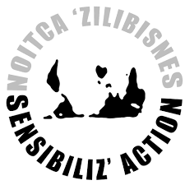
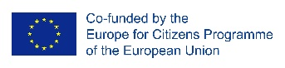
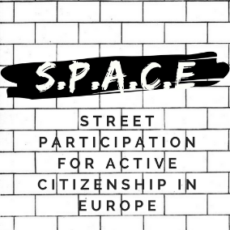

22 March 2019
Press release
SPACE: STREET PARTICIPATION FOR ACTIVE CITIZENSHIP IN EUROPE
THE FOURTH EVENT – „WORKSHOP ON STREET SENSITIZATION”
MARSEILLE, FRANCE

Starting from the 18th to the 21st of March 2019, the „Sensibiliz’Action” association was the host of the fourth international event of the „SPACE: Street Participation for Active Citizenship in Europe” project. The meeting took place in Marseille. At the meeting attended 25 international participants from 7 countries, as well as local citizens. The meeting focused on Street Sensitization Workshop.
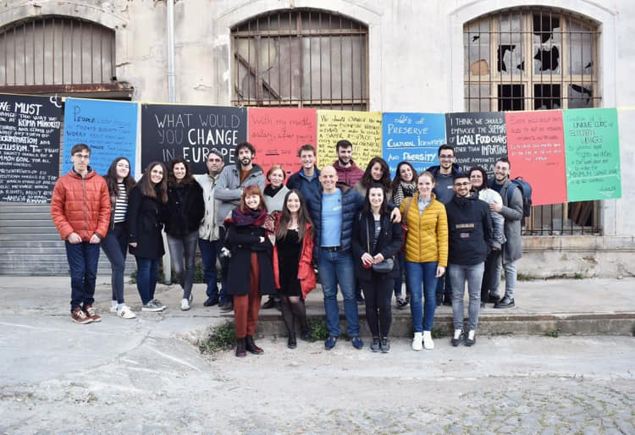
The 1st day began with welcoming the participants and getting to know each other activity. During this day, participants attended at two workshops: „Street Sensitization” and „European Tools of Participatory Democracy”. The next step was to prepare a street debate about the future of Europe. For this purpose, all participants were divided into groups in which they conducted surveys. Then the participants analysed the results of the surveys and drew conclusions.
In the 2nd day of the international event participants took part in a study visit in Gemenos. There they visited the „Fralib factory” and met with the workers of „Scop-Ti” Cooperative. After the lunch, presentation about the Popular Education process was done by Sensibiliz’Action. In the end, participants discovered the city through some Citizens’ Initiatives.
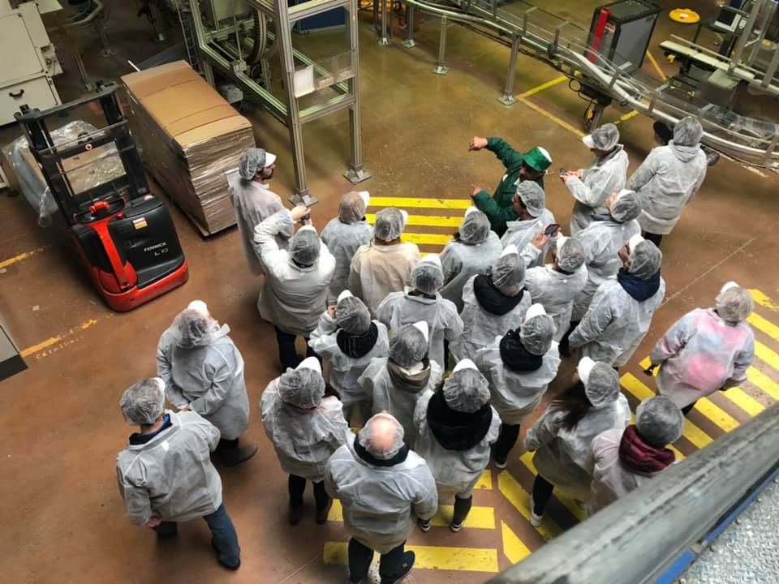

For more information on the event please visit: https://www.facebook.com/STREETPARTICIPATION/

