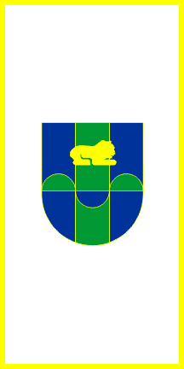
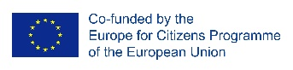
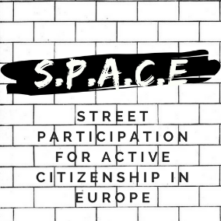

13 September 2019
Press release

SPACE: STREET PARTICIPATION FOR ACTIVE CITIZENSHIP IN EUROPE
THE SIXTH EVENT – „FINAL CONFERENCE”
TREBJNE, SLOVENIA

Starting from the 9th to the 12th of September 2019, Municipality of Trebjne was the host of the final international event of the „SPACE: Street Participation for Active Citizenship in Europe”project. The meeting took place in Trebjne. At the meeting attended 27 international participants from 8 countries, as well as local citizens. The final conference was dedicated to the promotion of the results of the project.
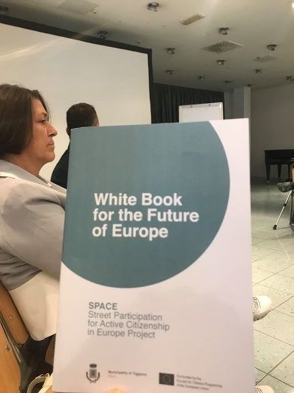
In the day of 9th of September, the project results and EU tools of Participative Democracy were presented. At the meeting attended and Mrs. Violeta Bulc, European Union Commissioner. In the park of Trebjne, took place the final street debate. The next item to the agenda was the workshop on SPACE project results and the presentation of the „White book for the future of Europe”.
The next day, on the 10th of Spetember, was dedicated to a study visit at a local initiative supported by European Union: Jurij’s homestead and Tem Catez. The last point of the international meeting was the project evaluation and the follow-up. This event allowed all the partners to evaluate and imagine further cooperation.
For more information on the event please visit: https://www.facebook.com/STREETPARTICIPATION/

